
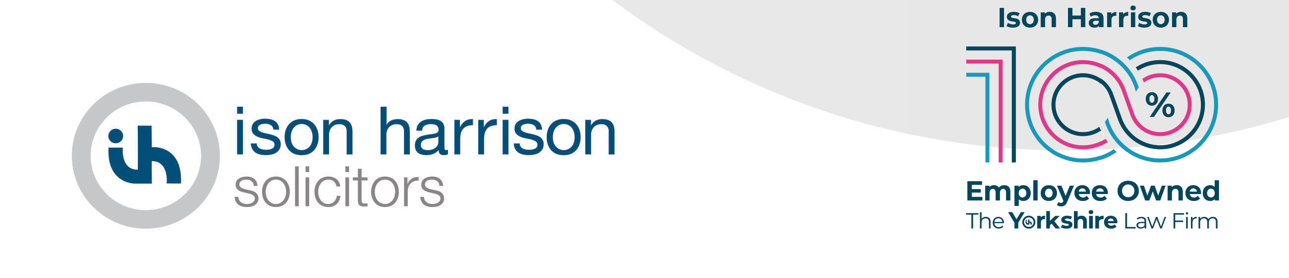

Complaints Policy

Our commitment
We want to give you the best possible service. However, if at any point you become unhappy or concerned about the service we have provided, or about the bill, then you should inform us immediately, so that we can do our best to resolve the problem. In the first instance, it may be helpful to contact the person who is working on your case, or their department manager, to discuss your concerns and we will do our best to resolve any issues at this stage.
If you are unhappy about any aspect of the service you have received, or about the bill, please contact the Customer Service Team (overseen by Jenny Bland, Head of Property departments) by post to our office at Duke House, 54 Wellington Street, Leeds, LS1 2EE, telephone 0113 200 7405 or email customerservice@isonharrison.co.uk. Making a complaint will not affect how we handle your case.

What will happen next?
- We will send you an email or letter acknowledging receipt of your complaint within three working days of receiving it, enclosing a copy of this procedure.

- We will investigate your complaint. This will normally involve passing your complaint to our Client Care Partner, who will review your matter file and speak to the member of staff who acted for you.

- We will send you a detailed written reply to your complaint within 14 working days of sending the acknowledgement email or letter. It is open to you to request a telephone meeting to discuss your complaint. We shall take into account anything further you wish to add with a view to responding within a further 5 working days.
- If you are still not satisfied, you should contact us again and we will arrange for another Partner within the firm, Emma Mason, Compliance Officer for Legal Practice, to review the decision.

- We will write to you within 14 days of receiving your request for a review confirming our final position in your complaint and explaining our reasons.

- If you are still not satisfied with our handling of your complaint you can ask the Legal Ombudsman to consider the complaint. We hope that this does not
become necessary and that we can resolve matters between ourselves. Contact details are as follows:
Legal Ombudsman
PO Box 6167
Slough
SL1 0EH
enquiries@legalombudsman.org.uk www.legalombudsman.org.uk

The Legal Ombudsman expects complaints to be made to them within one year of the date of the act or omission about which you are concerned, or within one year of you realising there was a concern. You must also refer your concerns to the Legal Ombudsman within six months of our final response to you.

- If we must change any of the above timescales, we will let you know and explain why.

Complaints about your bill
The above complaints procedure also applies to complaints arising concerning our bill. There may also be a right to object to the bill by applying to the court for an assessment of the bill under Part III of the Solicitors Act 1974; and that if all, or part, of a bill remains unpaid, the firm may be entitled to charge interest.

Raising concerns with our regulator
The Solicitors Regulation Authority (SRA) can help you if you are concerned about our behaviour. This could be for things like dishonesty, taking or losing your money or treating you unfairly because of your age, disability, or other characteristics. You can find information about raising your concerns with the SRA at SRA | Reporting a solicitor or firm to us | Solicitors Regulation Authority
If the practitioner is a Licensed Conveyancer, you can report misconduct to the Council for Licensed Conveyancers (CLC). You can find information about raising your concerns with the CLC at CLC-The Specialist Property Law Regulator
Alternatively, if the practitioner is a CILEX-accredited individual, you can report misconduct to the CILEx Regulation. You can find information about raising your concerns with CILEx Regulation at Problems and Complaints - CILEX Regulation

